**University of Michigan – Dearborn**

**CIS 150 – Computer Science 1**

**Lab# 11**

**Professor Bacha**

Demetrius Johnson

[meech@umich.edu](mailto:meech@umich.edu)

April 01, 2020

**Table Content**

Contents

Question 1 3

Test Cases 3

Source Code – see LAB 11 main.cpp –and—state.cpp 3

Screenshots 3

# Question 1

## Test Cases

|  |  |  |  |  |  |
| --- | --- | --- | --- | --- | --- |
| Test # | Valid / Invalid Data | Description of test | Input Value | Actual Output | Test Pass / Fail |
| 1 | valid | Test option 1 of your menu with any valid state that you’d like | See screenshot | See screenshot | pass |
| 2 | valid | Test option 2 of your menu with 1788 provided as input for the year. | See screenshot | See screenshot | pass |
| 3 | valid | Test option 2 of your menu with 2018 provided as input for the year. | See screenshot | See screenshot | pass |
| 4 | valid | Test option 3 of your menu. | See screenshot | See screenshot | pass |
| 5 | valid | Test option 1 invalid state abbreviation | See screenshot | See screenshot | pass |

## Source Code – see LAB 11 main.cpp –and—state.cpp

## Screenshots

TEST 1

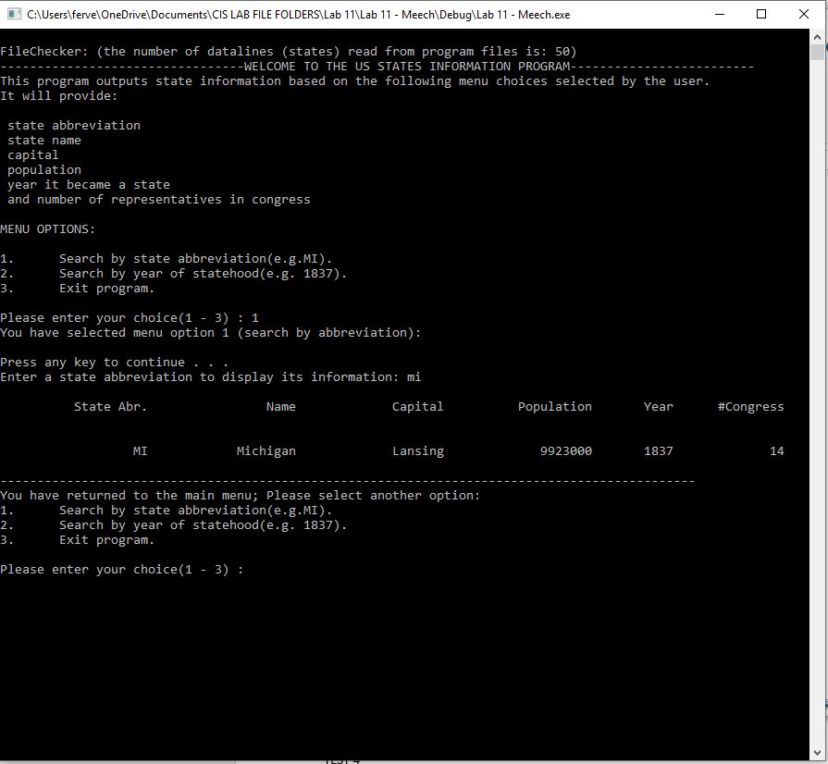

TEST 2

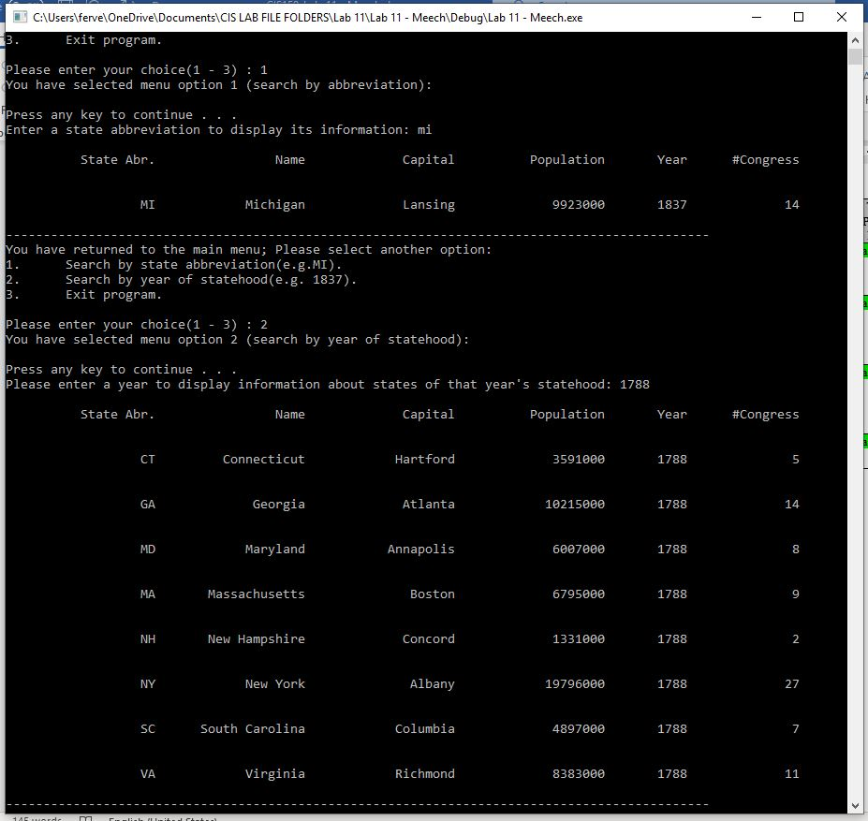

TEST 3

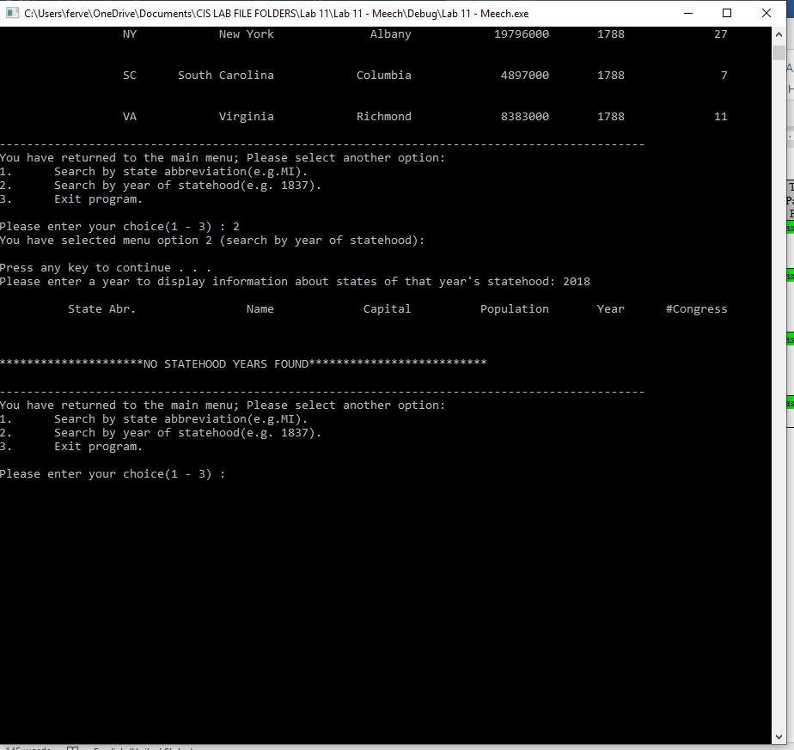

TEST 4

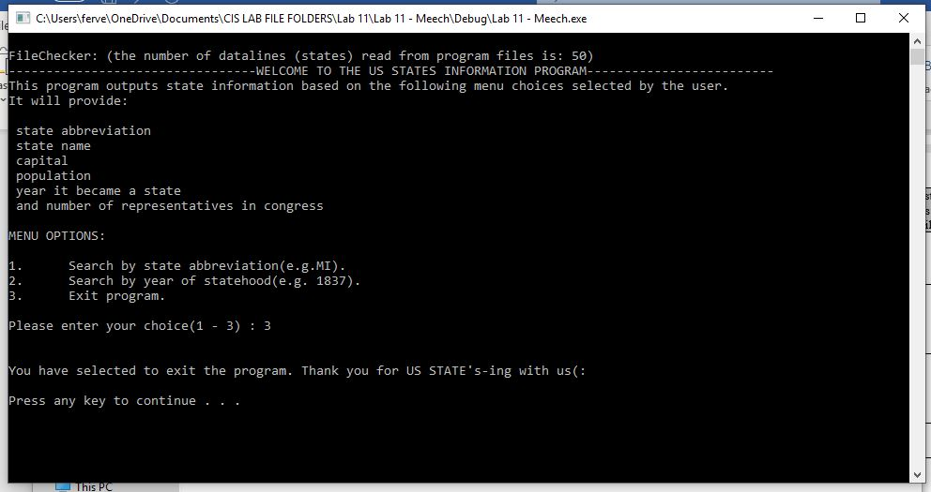

TEST 5

